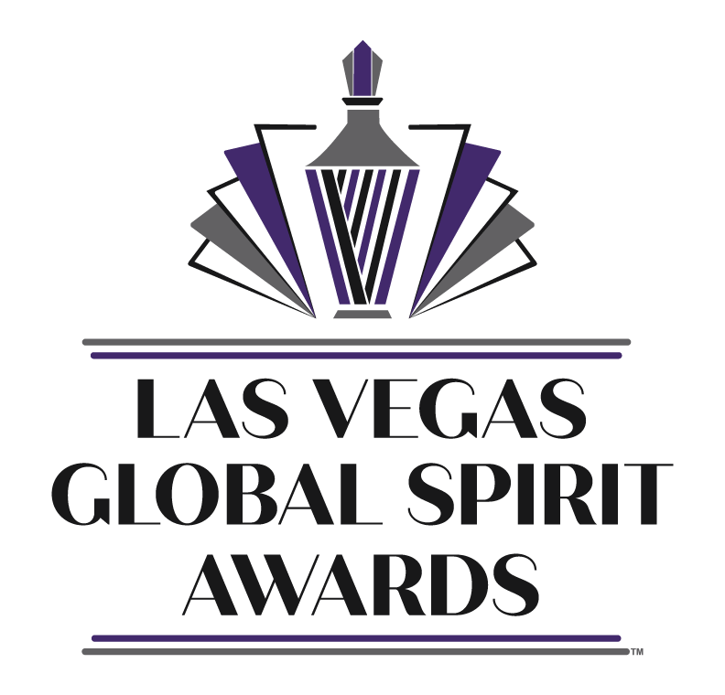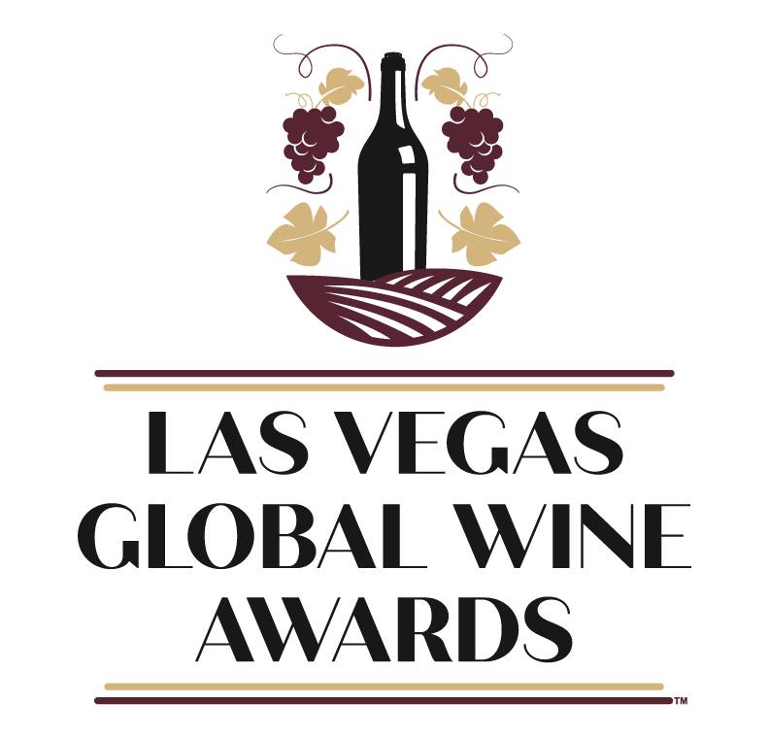
FOR IMMEDIATE RELEASE: February 21, 2023
Las Vegas Global Wine & Spirit Awards
Announces Distribution Partner
for 2023 Competitions
Las Vegas, NV – The Las Vegas Global Wine & Spirit Awards is proud to announce One Up Wine & Spirits, a division of Tian Beverage Distributor, as partner for the 2023 events. This partnership will allow *select winners to receive immediate distribution and showcase their products to the incredibly competitive and lucrative Las Vegas market.
The Las Vegas Global Wine & Spirit Awards is a prestigious event that recognizes and celebrates the best wines and spirits from around the world. The awards are known for their rigorous standards and impartial judging process, making them a highly coveted honor in the industry.
The 2023 awards will be held in Las Vegas, NV June 5-7 & June 12-14 and will feature a diverse range of wines and spirits from producers all over the world.
Tian Beverage Distributor is a leading independent provider of wine and spirit distribution services. With a vast network of retail and wholesale customers, One Up will ensure that the winning products receive the maximum recognition they deserve.
“It’s a great honor for One Up Wine & Spirits to be selected as the distribution partner for the 2023 Las Vegas Global Wine & Spirit Awards,” said AARON DIEC, owner of Tian. “We are very much looking forward to offering our distribution services to *select winners from this years competitions.”
“We are thrilled to partner with such a respected and influential company in the wine and spirit industry,” said EDDIE RIVKIN, Founder and CEO of the Las Vegas Global Wine & Spirit Awards. “Our partnership with One Up/Tian will allow us to further promote the *select winning products.”
“By adding up to 25 (each) award winning wines and spirits directly from this year’s competitions, the Las Vegas Global Wine & Spirit Awards affords entries an incredible opportunity not available from any other competition in the world.”
For more information and to enter the 2023 Las Vegas Global Wine & Spirit Awards, please visit the event websites at www.vegaswineawards.com & www.vegasspiritawards.com .
Contacts:
Eddie Rivkin, Founder & CEO
702.613.5350
Eddie@lvgwsa.com
Aaron Diec, Owner One Up Wine & Spirits / Tian Beverage Distributor
702.881.9100
info@oneupws.com
About Las Vegas Global Wine & Spirit Awards: The Las Vegas Global Wine & Spirit Awards is a premier event that recognizes and celebrates the best wines and spirits from around the world. The awards are known for their rigorous standards and impartial judging process, making them a highly coveted honor in the industry.
About Tian Beverage Distributor / One Up Wine & Spirits
One Up Wine & Spirits is the craft beverage and education division of Tian Beverage Distributor. One Up’s portfolio is comprised of unique award-winning beverages featuring everything from non-alcoholic beverages, fine wines and distilled spirits.

